Chains in LangChain
https://www.youtube.com/watch?v=5hjrPILA3-8&list=PLKnIA16_RmvaTbihpo4MtzVm4XOQa0ER0&index=9
https://github.com/campusx-official/langchain-chains
00:00 – Intro
00:41 – Recap
02:42 - What & Why
08:11 - Simple Chain
14:30 - Sequential Chain
19:48 - Parallel Chain
32:36 - Conditional Chains
1. Introduction to LangChain Chains

1.1 Overview
LangChain Chains are one of the most important components of the LangChain framework.
They allow developers to connect multiple steps involved in an LLM-based application into a single automated workflow (pipeline).
This topic is so central to LangChain that the framework itself is named after the concept of "Chains".
The Chains component is covered across multiple videos:
- This video focuses on the fundamentals of chains and basic types
- The next video focuses on the internal working of chains and the Runnable concept

1.2 Objectives of This Section
In this video, we will:
- Understand what chains are
- Learn why chains are needed
- Build a simple chain
- Create different types of chains:
  - Sequential Chains
  - Parallel Chains
  - Conditional Chains

2. Recap of Previously Covered Concepts

2.1 LangChain Components Covered So Far
Before introducing chains, the following major components were discussed:
2.1.1 Models Component
This component focuses on:
- Interacting with different AI models
- Sending prompts to LLMs
- Receiving responses

2.1.2 Prompts Component
This component covers:
- Designing prompt templates
- Sending different types of inputs to LLMs
- Dynamically filling prompt variables

2.1.3 Structured Output and Output Parsers
Although not a core LangChain component, structured output is essential in LLM applications.
Topics covered:
- Generating structured data from LLMs
- Using Output Parsers:
  - String Output Parser
  - JSON Output Parser
  - Other parsers

2.2 Transition to Chains Component
With this video, we begin learning a new major LangChain component:
👉 Chains
Chains help automate and manage multi-step LLM workflows.

3. What are Chains and Why They Are Needed

3.1 Multi-Step Nature of LLM Applications
Most LLM-based applications are made of multiple smaller steps.
A simple application usually involves:
- Taking user input (prompt)
- Sending the prompt to the LLM
- Receiving and processing the response
- Displaying the output
Even this basic flow includes multiple operations.

3.2 Manual Approach Without Chains
Before chains, the workflow is handled manually:
- Create a PromptTemplate
- Invoke the prompt with user input
- Send formatted prompt to the model
- Call the model invoke method
- Receive output with metadata
- Extract content from response
- Display result
This approach becomes:
- Repetitive
- Hard to manage for large applications
- Difficult to scale for complex logic

3.3 Concept of Pipelines Using Chains
Chains solve this problem by creating automated pipelines.
A chain connects multiple steps such that:
- Output of Step 1 becomes input of Step 2
- Output of Step 2 becomes input of Step 3
- And so on
Once the pipeline is built:
- You only provide input to the first step
- Trigger the chain once
- The entire workflow executes automatically

3.4 Advantages of Using Chains
Chains provide:
- Automation of multi-step workflows
- Clean and readable code
- Better scalability
- Easier maintenance

3.5 Different Structures of Chains
LangChain supports multiple pipeline structures:
3.5.1 Sequential Chains
Steps execute one after another in order.

3.5.2 Parallel Chains
Multiple chains run simultaneously.

3.5.3 Conditional Chains
Chains execute based on conditions or logic.

These structures allow building highly complex applications easily.

- Simple Chain in LangChain
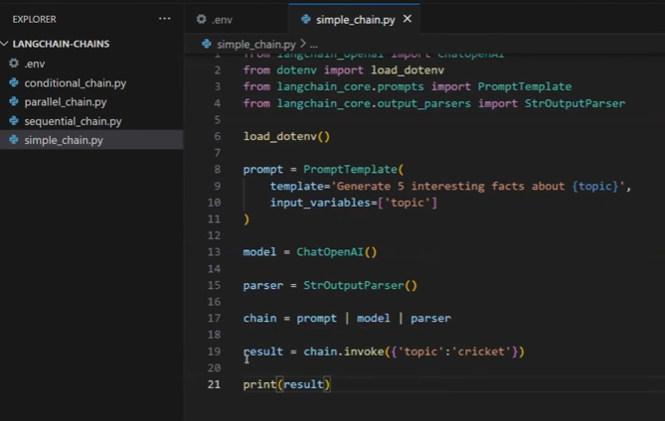

4.1 Purpose of a Simple Chain
Before creating complex chains, a simple chain is introduced to understand:
- Basic pipeline creation
- Component connection
- Automatic execution

4.2 Steps in the Simple Chain Example
The simple chain consists of three steps:
- Accept topic input from user
- Send topic to LLM
- Display processed output
The goal is to generate:
👉 Five interesting facts about a given topic

4.3 Required Components
The simple chain uses:
- PromptTemplate
- ChatOpenAI (LLM model)
- StringOutputParser

4.4 Creating the Prompt Template
The prompt template is designed as:
- Ask for five interesting facts about a topic
- Use a variable called topic
Conceptual structure:
Generate five interesting facts about {topic}

4.5 Initializing the Model
The ChatOpenAI model is initialized with:
- Default model settings
- Option to specify custom model if required

4.6 Initializing the Output Parser
The String Output Parser is used to:
- Extract clean text output from the model response

4.7 Forming the Chain Using LangChain Expression Language (LCEL)
The chain is created using the pipe operator (|):
Conceptual pipeline:
PromptTemplate | Model | StringOutputParser
This syntax is called:
👉 LangChain Expression Language (LCEL)
It declaratively connects components.

4.8 Executing the Chain
To run the chain:
- Call the invoke() method
- Provide input only to the first step
Example input:
topic = "Cricket"

Execution Flow:
- Topic fills the prompt template
- Prompt is sent to the LLM
- LLM returns response
- Output parser extracts clean text
- Final result is returned

4.9 Output of the Simple Chain
The output is:
- A plain string containing five interesting facts about the topic
No manual parsing or metadata handling is required.

4.10 Visualizing the Chain
LangChain allows visualizing the pipeline using:
chain.get_graph().print_ascii()
This displays:
- Prompt step
- Model step
- Parser step
in a connected flow diagram.

5. Sequential Chain in LangChain

5.1 Concept of Sequential Chains
A Sequential Chain is a pipeline where:
- One step executes after another
- Output of each step becomes input for the next step
It is useful when:
- Tasks depend on previous results
- Multiple LLM calls are required in sequence

5.2 Use Case Example
The application flow:
- User provides a topic (e.g., "Unemployment in India")
- LLM generates a detailed report on the topic
- The detailed report is sent again to the LLM
- LLM extracts a five-point summary from the report
This creates an automated summarization pipeline.
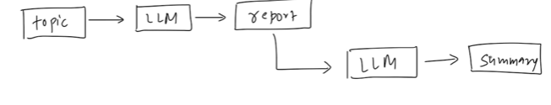

5.3 Components Used
The sequential chain uses:
- Two PromptTemplates
- One LLM model (ChatOpenAI)
- One StringOutputParser

5.4 First Prompt Template – Generate Detailed Report
Purpose:
Ask the LLM to generate a detailed report on a topic.
Structure:
Generate a detailed report on {topic}
Input Variable:
- Topic
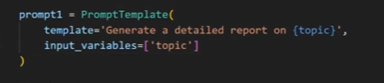

5.5 Second Prompt Template – Generate Summary
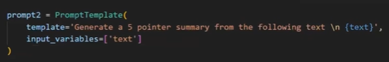
Purpose:
Ask the LLM to extract a five-point summary from the report.
Structure:
Generate a five-point summary from the following text:
{text}
Input Variable:
- text

5.6 Model and Output Parser
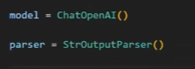
Model
- ChatOpenAI is used as the LLM
Output Parser
- StringOutputParser extracts clean text output

5.7 Creating the Sequential Chain
The chain pipeline is formed as:
- Prompt 1 → Model → Parser
- Output flows into Prompt 2 → Model → Parser
This connects both steps in sequence.

5.8 Executing the Sequential Chain
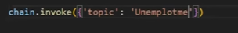
Input example:
topic = "Unemployment in India"
Execution process:
- Topic fills first prompt
- LLM generates detailed report
- Report is parsed as plain text
- Parsed text fills second prompt
- LLM generates five-point summary
- Final output is returned

5.9 Output
The final result is:
- A five-point summarized version of the detailed report

5.10 Visualizing the Sequential Chain
Using:
chain.get_graph().print_ascii()
This shows:
- First prompt → model → parser
- Second prompt → model → parser
connected in sequence.

6. Parallel Chain in LangChain

6.1 Concept of Parallel Chains
Parallel Chains allow:
- Multiple chains to execute simultaneously
- Same input to be processed in different ways
They are useful when:
- Independent tasks can run at the same time
- Results need to be merged later

6.2 Use Case Example
Application goal:
From a large document:
- Generate short notes
- Generate quiz (question-answers)
Then:
- Merge both outputs into a single document
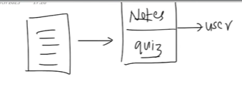

6.3 Architecture Overview
The pipeline consists of:
Parallel Execution:
- Chain A → Generates notes
- Chain B → Generates quiz
Merge Step:
- Outputs from Chain A and Chain B are sent to another LLM
- LLM merges both into one final document
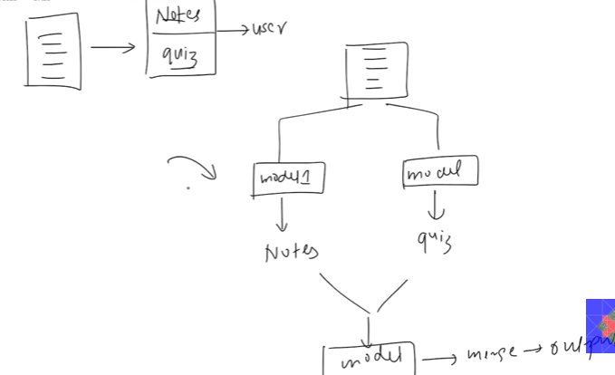

6.4 Models Used
Two models are used in parallel:
- ChatOpenAI (for notes generation)
- ChatAnthropic (for quiz generation)
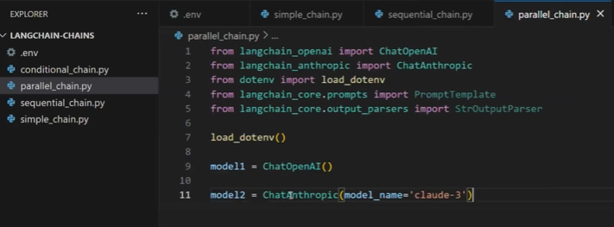

6.5 Prompt Templates
6.5.1 Notes Generation Prompt
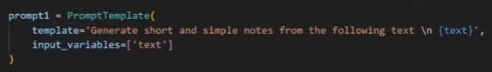
Structure:
Generate short and simple notes from the following text:

{text}
Input Variable:
- text

6.5.2 Quiz Generation Prompt
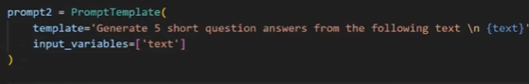
Structure:
Generate five short question answers from the following text:

{text}
Input Variable:
- text

6.5.3 Merge Prompt
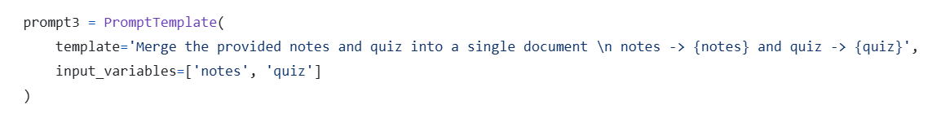
Purpose:
Combine notes and quiz into a single document.
Structure:
Merge the provided notes and quiz into a single document:

Notes:
{notes}

Quiz:
{quiz}
Input Variables:
- notes
- quiz

6.6 Output Parser
- StringOutputParser is used to extract text output
- 
We will create in the things in two parts:
- Parallel and merging
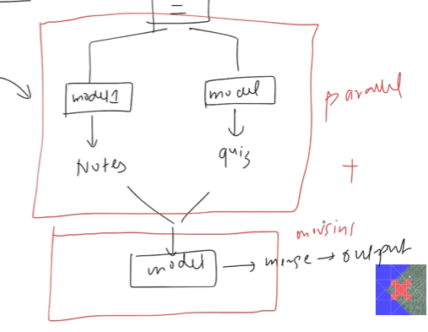

6.7 RunnableParallel for Parallel Execution
LangChain provides:
👉 RunnableParallel
This allows:
- Running multiple chains at the same time
- Returning results as a dictionary
Example structure conceptually:
RunnableParallel({
"notes": notes_chain,
"quiz": quiz_chain
})
RunnableParallel which can execute multiple models simultaneously
It takes the dictionary and give some name to both the chains
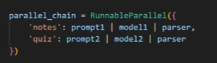

6.8 Building the Parallel Chains
Notes Chain:
Prompt 1 → Model 1 → Parser
Quiz Chain:
Prompt 2 → Model 2 → Parser
Both chains execute simultaneously.

6.9 Creating the Merge Chain
Merge Chain is sequential:
Merge Prompt → Model → Parser
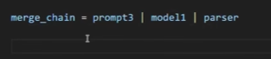

6.10 Final Chain Construction
The complete pipeline:
Parallel Chain → Merge Chain
This connects:
- Parallel processing
- Followed by merging
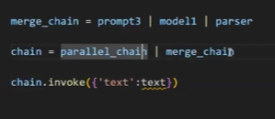

6.11 Executing the Parallel Chain
Input:
- A large document text
Execution flow:
- Text goes to both parallel chains
- Notes and quiz generated simultaneously
- Both outputs sent to merge chain
- Final combined document returned

6.12 Output
The final output contains:
- Generated notes
- Generated quiz
- Combined into one formatted document

6.13 Visualizing the Parallel Chain
Using:
chain.get_graph().print_ascii()
Displays:
- Two parallel branches
- Merge step
- Final output

7. Conditional Chains
Conditional Chains are used when we want to execute only one path based on a condition — similar to an if-else statement in programming.
Example Scenario: Sentiment-Based Response System
Suppose we receive customer feedback from Amazon. We want to:
- Detect whether the sentiment is Positive or Negative.
- Based on the sentiment:
  - If Positive → Send a positive reply (e.g., thanking the customer)
  - If Negative → Send an appropriate negative response
In real applications with agents and tools:
- Positive feedback → Send feedback form or request a 5-star rating.
- Negative feedback → Send an email automatically to customer support.
For now, we keep it simple by just generating responses based on sentiment.
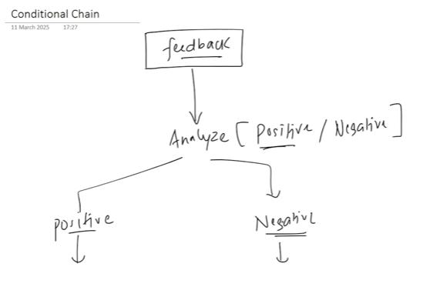
Using agents further we can develop like – if it is positive response then give the feedback form for the customer to give the ratings and if it is the negative feedback then send the email to the customer support

Flow of Conditional Chain
- User provides feedback.
- Model classifies sentiment (Positive / Negative).
- Based on sentiment, only one branch executes (not both).
Unlike Parallel Chains, only one path runs at a time.

Step 1: Setup (Imports and Model)
We reuse common imports and create:
- ChatOpenAI model.
- StringOutputParser.
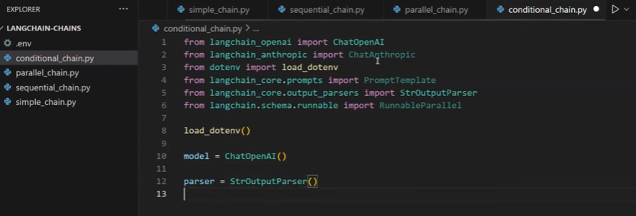

Step 2: Create Classification Prompt
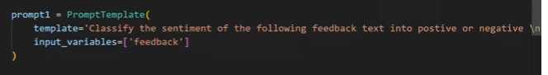
Prompt 1:
Purpose: Classify feedback sentiment.
Template:
Classify the sentiment of the following feedback text into Positive and Negative:
{feedback}
Input variable:
- feedback

Step 3: Build Classification Chain
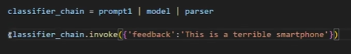
Chain flow:
Prompt → Model → Output Parser
Test example:
Feedback: "This is a terrible smartphone"
Output: Negative
Problem: LLM output can vary, e.g.:
- "The sentiment is negative"
- "This is a positive sentiment"
This inconsistency can break the branch logic.
We want the structured output and want the consistent result so we use the pydanticOutputparser

Step 4: Structured Output with Pydantic Parser
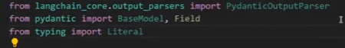
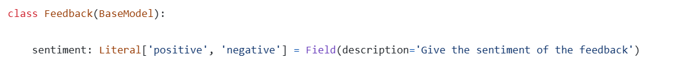
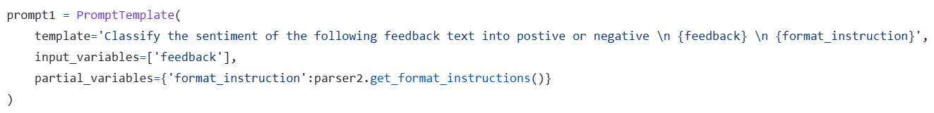
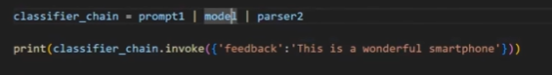
It gives the structured output
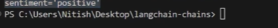
Define a Pydantic model:
Class: Feedback
Field:
- sentiment → Literal["Positive", "Negative"]
This ensures the output is always consistent. Possible values:
- Positive
- Negative
Extract result with:
result.sentiment

From above we can get .sentiment and print it
Now we classified the prompt into positive and negative and next we need to do branching

Step 5: Create Branch Prompts
Two response prompts:
- Positive Response Prompt: Write an appropriate response for positive feedback.
- Negative Response Prompt: Write an appropriate response for negative feedback.

Step 6: Implement Branching using RunnableBranch
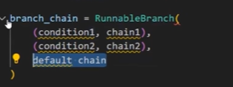
Runnable have the tupples – If condition2 satisfied then run chain1. If condition2 satisfied then run chain2 if not both then run default chain
We need to create two more prompts
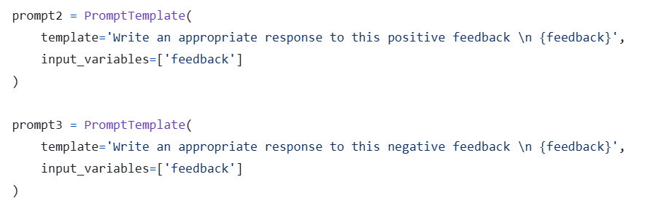
These prompts are for the positive and negative feedbacks
RunnableBranch allows conditional execution:
if condition1 → run chain1
elif condition2 → run chain2
else → run default chain
Each condition is a tuple:
- (condition, chain)

Step 7: Define Conditions
Below is for executing the default chain
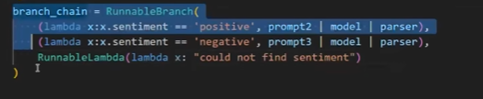
X contains the sentiment based on which we are calling the model
Condition 1:
- If sentiment == "Positive" → Run Positive Response Chain
Condition 2:
- If sentiment == "Negative" → Run Negative Response Chain
Default chain (if no condition matches):
- Return a simple message: "Could not find sentiment"

Step 8: Final Chain Execution
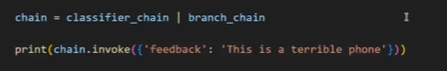
- Pass user feedback to the classification chain.
- Classification output is passed to RunnableBranch.
- RunnableBranch executes only one branch based on sentiment.
- Output is returned consistently, e.g.:
  - Positive → "Thank you for your kind words!"
  - Negative → "We are sorry to hear about your experience."
We can also print and check the chain how they are executed

Summary
With this, we have learned three types of chains:
- Parallel Chains
- Sequential Chains
- Conditional Chains
- Conditional Chains are crucial when only one path should execute based on a specific condition.
- This concept will also be useful when building agents in future lessons.
- Runnable is the key concept for making functions or lambda functions behave like chains.
In the next video, the instructor will explain Runnable in detail and show how chains are connected behind the scenes in LangChain.

